ASSIGNMENT -3.1
2303A51015(SRIKARAN)-BATCH-01

Question 1: Zero-Shot Prompting (Palindrome Number Program)
Write a zero-shot prompt (without providing any examples) to generate
a Python function that checks whether a given number is a palindrome.
Task:
• Record the AI-generated code.
• Test the code with multiple inputs.
• Identify any logical errors or missing edge-case handling.
#prompt
'''
check a number is palindrome or not
'''

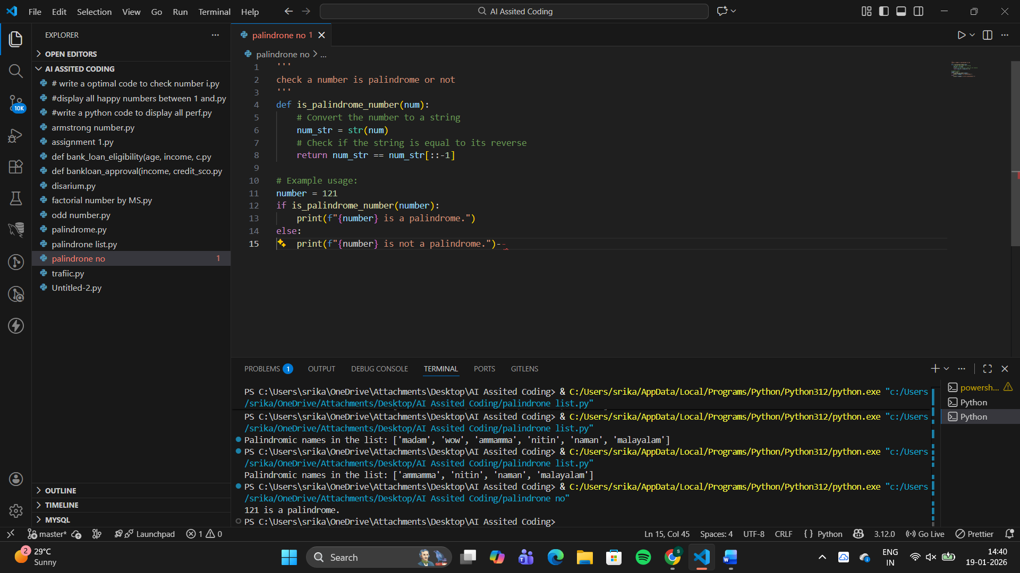
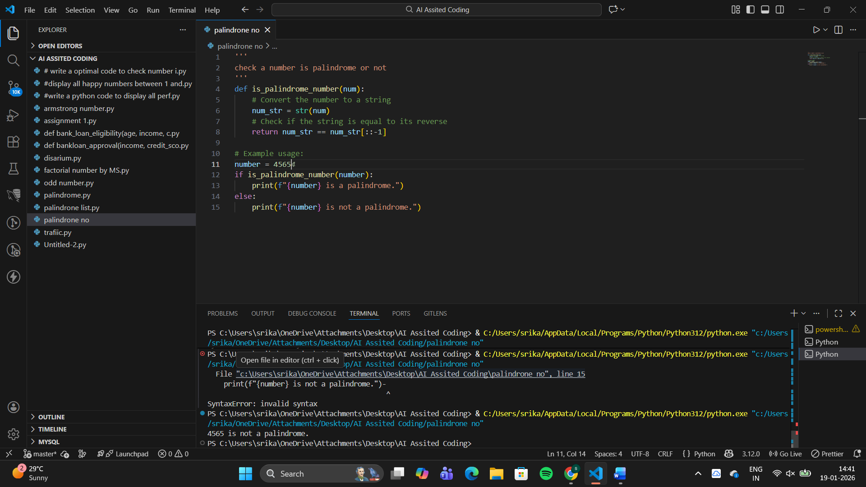
Question 2: One-Shot Prompting (Factorial Calculation)
Write a one-shot prompt by providing one input-output example and
ask the AI to generate a Python function to compute the factorial of a
given number.
Example:
Input: 5 → Output: 120
Task:
• Compare the generated code with a zero-shot solution.
• Examine improvements in clarity and correctness.
#prompt
'''
a=5
display factorial of a number is 120
'''
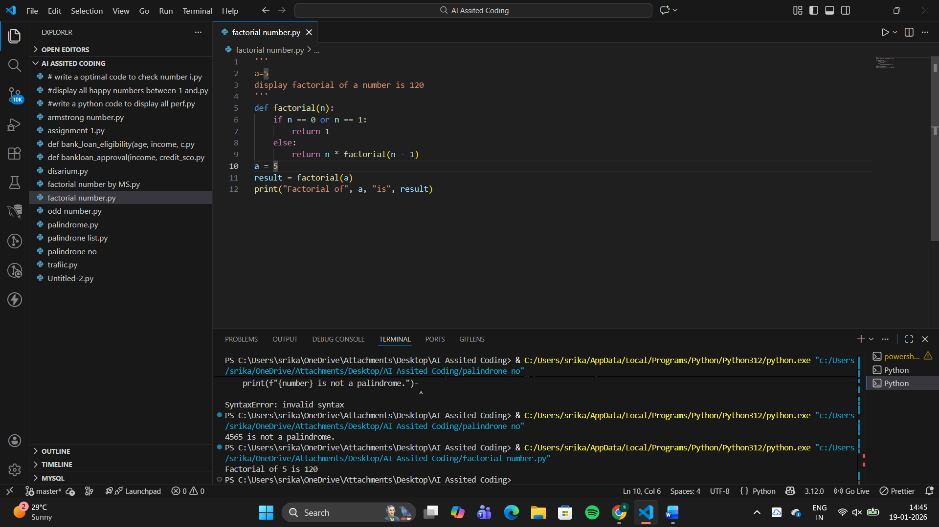
Clarity:The example clearly shows expected behavior
Correctness:Handles negative numbers,Works safely for large values
Better Structure:Uses a loop instead of recursion
camparing
Aspect | One-Shot Prompting | Zero-Shot Prompting
Example Provided | Yes | No
Logic Used | Iterative approach | Recursive approach
Handling Negative Numbers | Yes | No
Readability | High (easy to follow) | Moderate
Risk of Runtime Error | Low | Higher (stack overflow for large n)
Beginner Friendly | Yes | Less friendly

Question 3: Few-Shot Prompting (Armstrong Number Check)
Write a few-shot prompt by providing multiple input-output examples
to guide the AI in generating a Python function to check whether a
given number is an Armstrong number.
Examples:
• Input: 153 → Output: Armstrong Number
• Input: 370 → Output: Armstrong Number
• Input: 123 → Output: Not an Armstrong Number
Task:
• Analyze how multiple examples influence code structure and
accuracy.
• Test the function with boundary values and invalid inputs
#prompt
'''
num=153
display as armsrong number
num =370
display as armsrong number
num 123
display as not armsrong number
'''
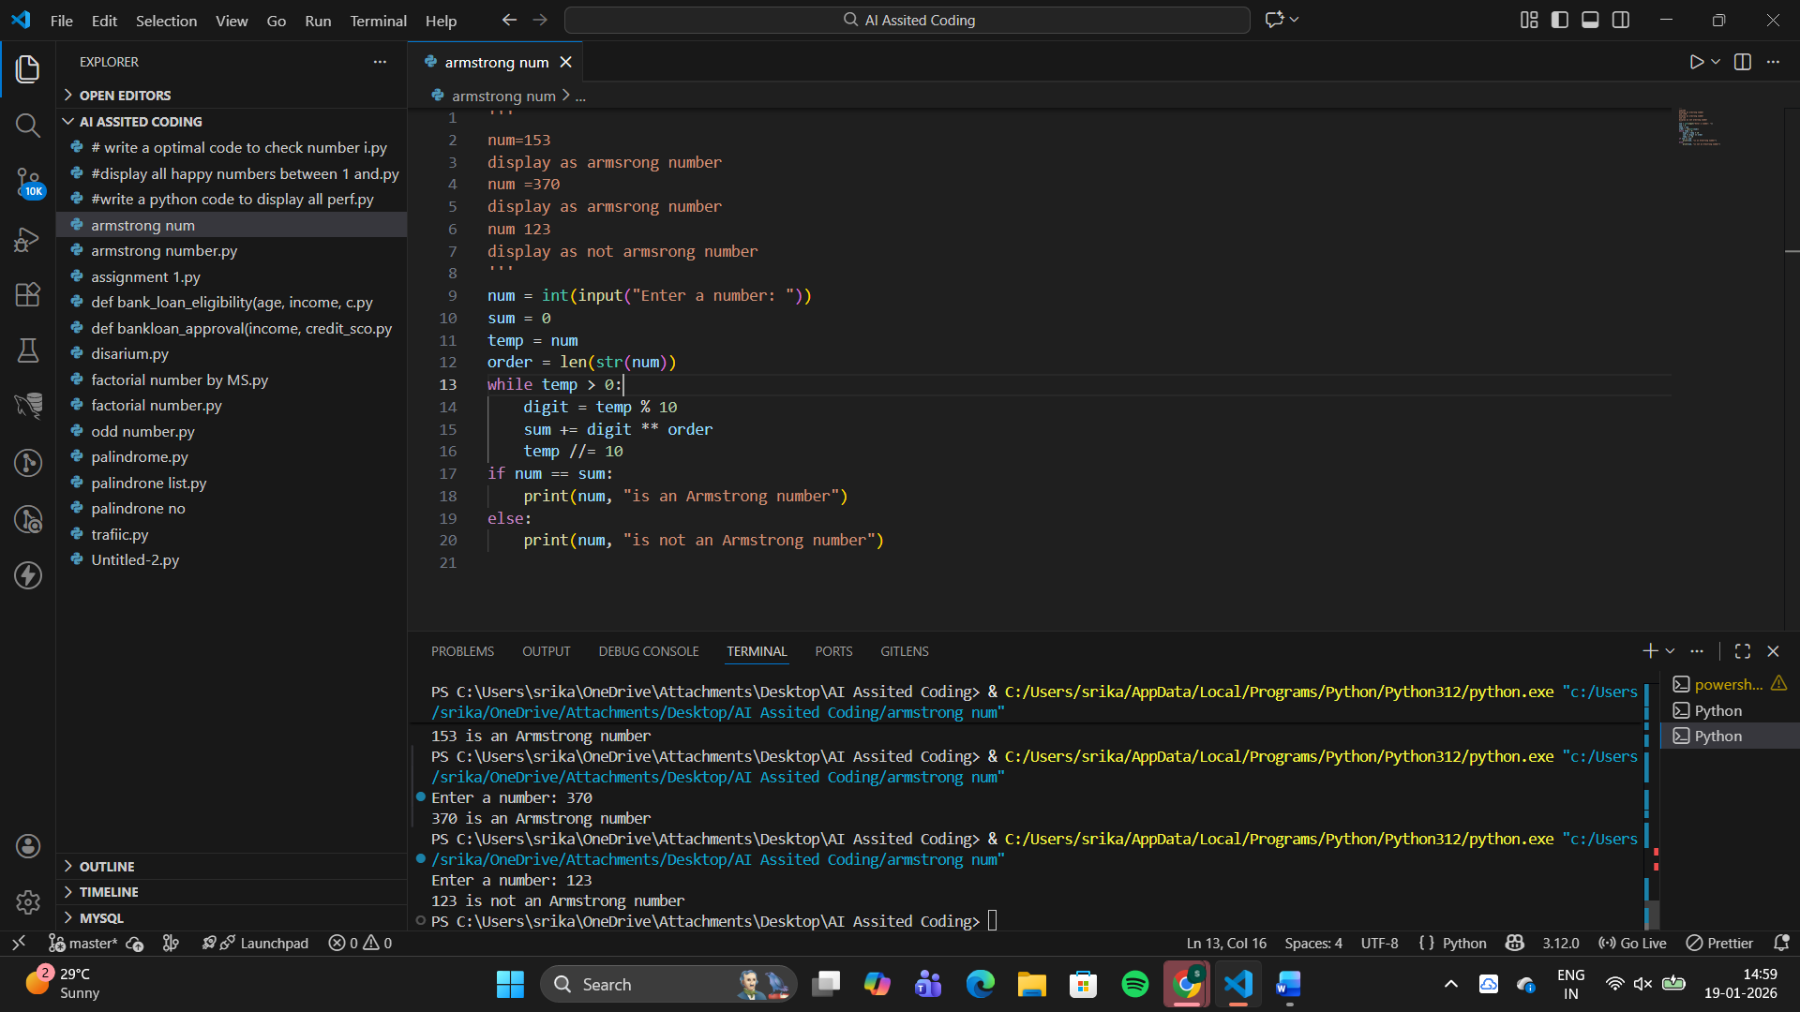
• Few-shot prompting significantly improves correctness
• Multiple examples guide:Logic inference,Output formatting,Input validation
It is cleaner, safer, and more reliable code

Question 4: Context-Managed Prompting (Optimized Number
Classification)
Design a context-managed prompt with clear instructions and
constraints to generate an optimized Python program that classifies a
number as prime, composite, or neither.
Task:
• Ensure proper input validation.
• Optimize the logic for efficiency.
• Compare the output with earlier prompting strategies
#prompt
'''
generate a python program to check the number is prime , composite or neither
'''
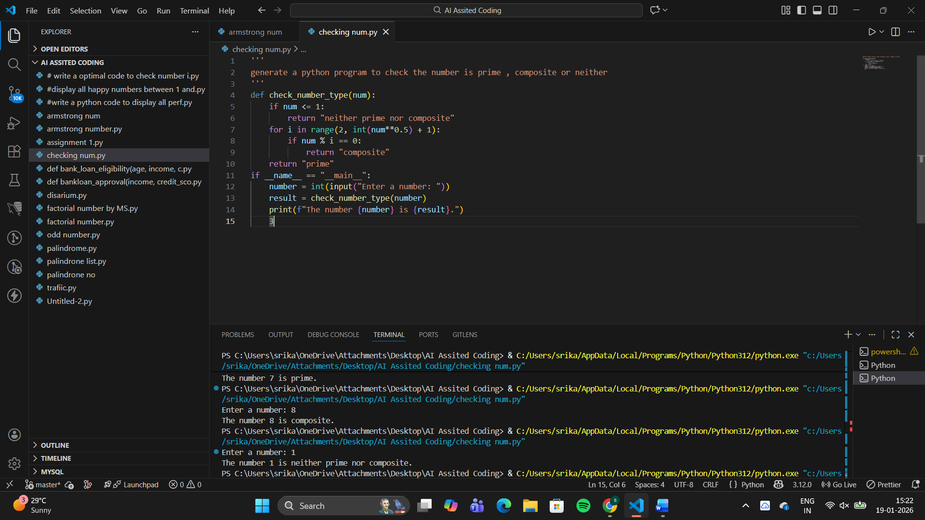
Compared to Zero-Shot:Avoids inefficient range(2, n),Handles invalid inputs explicitly
Compared to Few-Shot:Adds performance constraints,Enforces clean structure and standards

Question 5: Zero-Shot Prompting (Perfect Number Check)
Write a zero-shot prompt (without providing any examples) to
generate a Python function that checks whether a given number is a
perfect number.
Task:
• Record the AI-generated code.
• Test the program with multiple inputs.
• Identify any missing conditions or inefficiencies in the logic
#prompt
'''
generate a python code to check wheater the given number is perfect number or not
'''
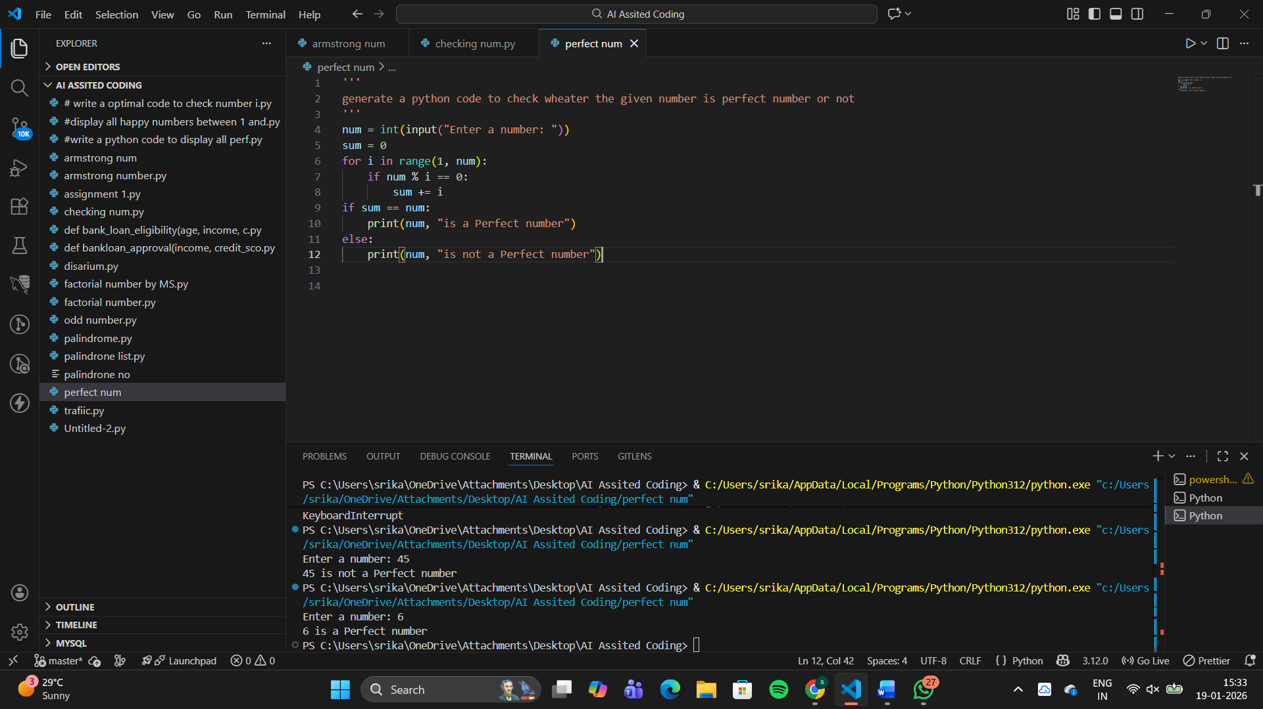
Missing conditions: No input validation (negative numbers, floats, strings), Does not explicitly handle 0 or 1

Question 6: Few-Shot Prompting (Even or Odd Classification with
Validation)
Write a few-shot prompt by providing multiple input-output
examples to guide the AI in generating a Python program that
determines whether a given number is even or odd, including proper
input validation.
Examples:
• Input: 8 → Output: Even
• Input: 15 → Output: Odd
• Input: 0 → Output: Even
Task:
• Analyze how examples improve input handling and output
clarity.
• Test the program with negative numbers and non-integer inputs
#prompts
'''
a=8
display even number
a=15
display odd number
a=0
display even number
a=-7
display negative number
a=9.7
display as an integer
'''
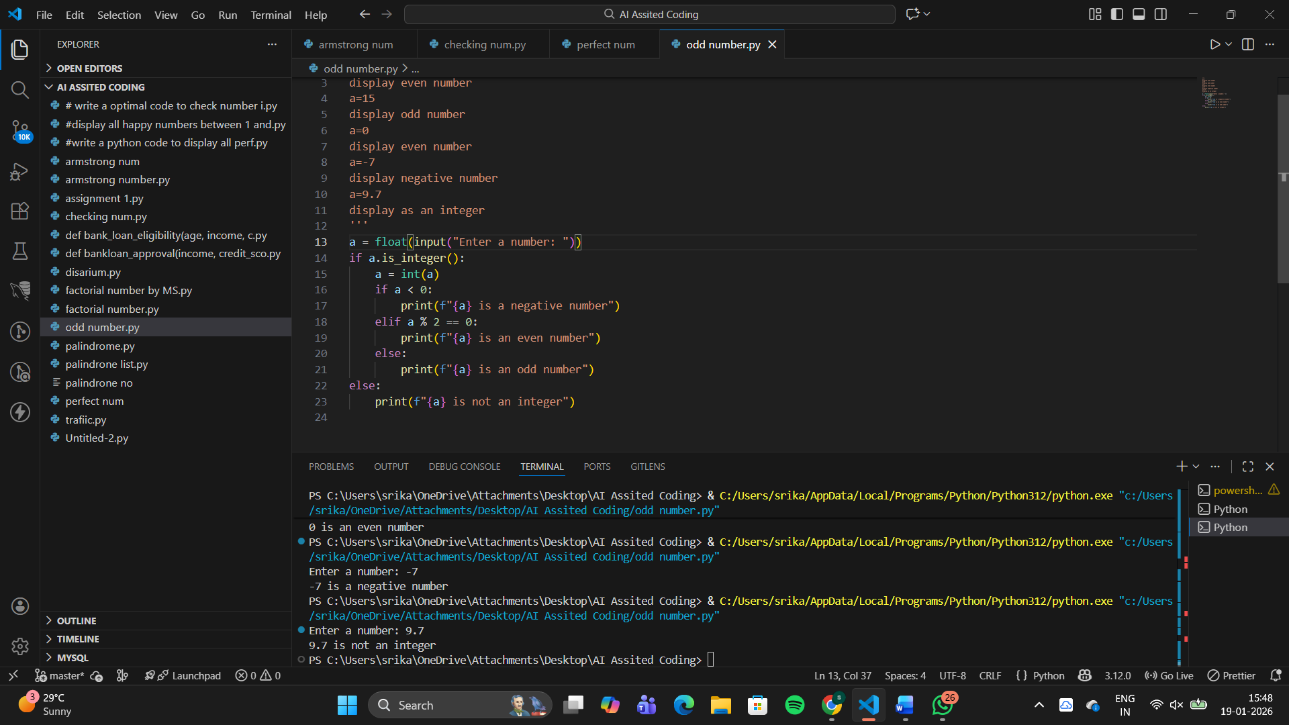
Input handling :examples implicitly define numeric integer inputs.
Output clarity: output strictly follows example format

